The Denver Alumnae Chapter
Of
Delta Sigma Theta Sorority, Inc.
Invites you to join us for:
Delta GEMS Open House
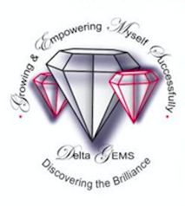

Date: Saturday, October 29, 2016
Time: 10:00 – 11:30am
Location: University of Denver
Driscoll Student Center — Room 145
2055 East Evans Ave. |Denver, CO 80210
Delta GEMS is a mentoring program designed for young African American women ages 14-18.

The goals for Delta GEMS are:

- To instill the need to excel academically
- To provide tools that enable girls to sharpen and enhance their skills to achieve high levels of academic success;
- To assist girls in proper goal setting and planning for their futures high school and beyond; and
- To create compassionate, caring, and community minded young women by actively involving them in service learning and community service opportunities.

We look forward to you joining us at the Delta GEMS open house. Applications will be provided.
For more information, please contact Delta GEMS co-chairs via email at denverdeltagems@gmail.com.

